HRA LEGAL

@AMEY:

1. Website reference for our firm. The closest that I can provide is the CAM website. There are many great websites of law firms, but the way my content is, I believe this is apt for you to understand and relate.
2. COLOR: Either needs a little tone down beige or sand color. This is too much brown. OR preferably if you can use this same exact color combo (slight beige-peach) as shown on <https://www.artisanlab.in/>.
3. FONTS: Ours needs to be 2 sizes less. We have to work on space & font legibility. Refer CAM here as well. Pls see their header and footer is so sleek, with small but legible fonts, also the entire content and pointers are small yet precise and sharp. You can use Helvetica or Proxima.
4. Firm Name: Need HRA Legal to be looking like the below image. Can you do it for now- bracketed form? I could in ppt which I sent to you earlier, in word I cannot. Hence, I’ve pasted image here for you to replicate.

1. Red Color: keep firm name in same color “black” and when you take the cursor you can make it change to “entire red colored font” or “red underlined HRA LEGAL, with shapes changing into dark beige”?
2. Icons: We can use less of icons in Practice Areas and instead keep bullets like “Corporate “ in this form. I mean don’t use icons everywhere. It dilutes the aesthetics.
3. Header titles: Change it to red colored font with red underlined. All headers have sub-headers, Refer CAM - we need exactly same. Pls hover around and see once
4. Footer: See CAM – their footer is sleek. With location and links ton social media pages etc. All info fits here perfectly in half page.
5. Consistency: Here too refer CAM. Even for HRA Legal: Our main tabs are “Home, About Us, Practice Areas, Sectors, Knowledge Centre, Contact Us”. Wherever you link these tabs the content should remain same and consistent including the titles/categories etc
6. Home Page Revisions:
   1. “Get Legal Consultation”: Don’t highlight it much. Can keep same color with maybe underlined in diff color. Although I’d like to delete but we can retain for leads and ease of access.
   2. Home page Start: We really need to work on this. If the visual is not happening, then let me know if I should give you Our own office pics which you can use as watermark background, OR if you want to use certain professional general image as a background; and in center mention “HRA Legal and its intro etc” or we can mention some quote.

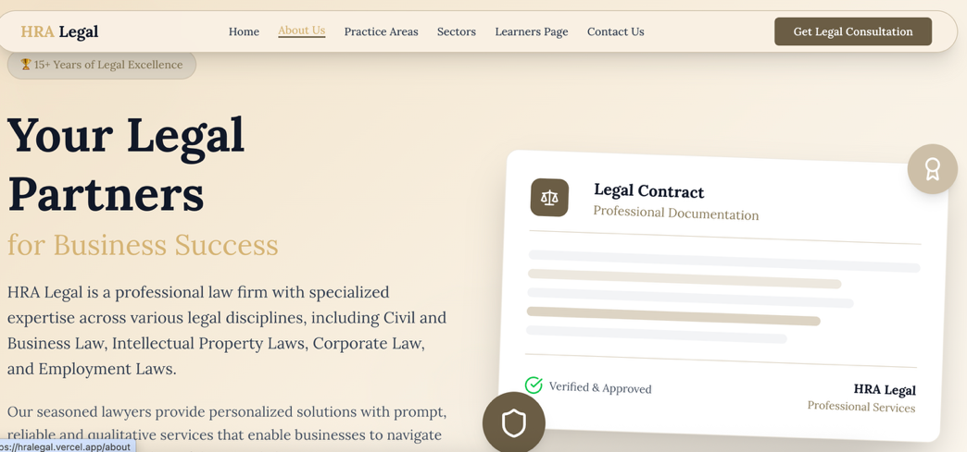

* 1. Trusted by: delete.
  2. Why Choose us: Don’t write twice. In brown circle its fine. Then no need to write in full question mark sentence. Everything else is fine with icons and content.

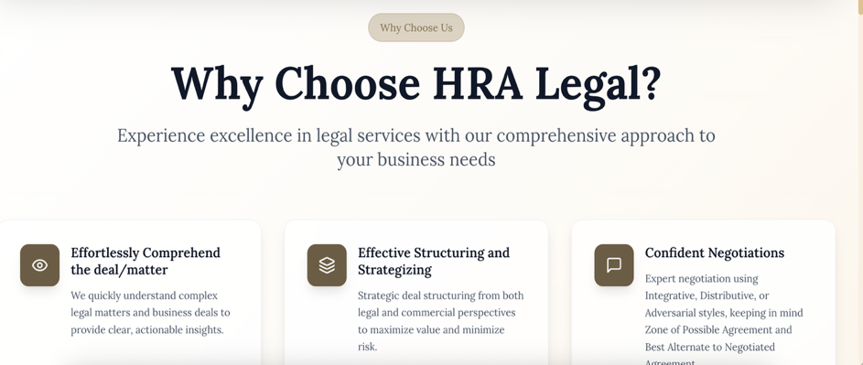



* 1. Ready to experience : Delete entirely
  2. Services:

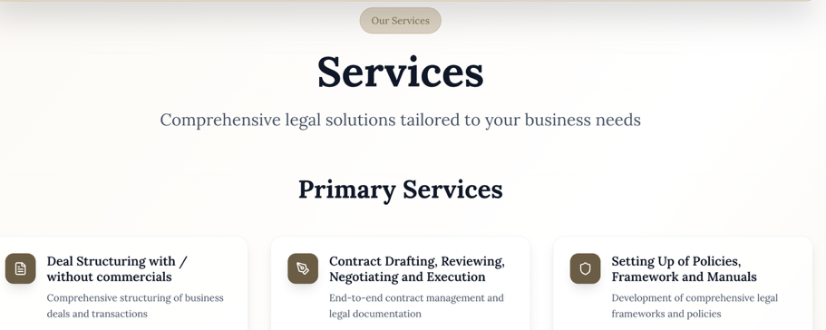



Again, no need to mention twice. Rest is fine including icons and content. Just that delete “End to End Legal Services” sentence and let it either appear after secondary services or can change and move above before primary services.

* 1. Practice Areas on Home Page: This is most important for me.
     + You can refer CAM pls. that’s perfect for practice areas. You can see where and how they appear on pages and whether it appears on Home page or expertise page, it takes you to same content. We can use same method.
     + Don’t use different terminology of categories. Has to be same.
     + Also, under “Practice Areas – Expertise Areas and Developing Areas” are sub headers”. See sub headers created by them as well.

* 1. Need legal assistance: delete. One on topmost header and plus at footer contact us is more than enuf. We don’t need to repeat so many times
  2. Your trusted legal partner: delete. These are not true facts. Also, these are facts of my employment so these can be mentioned where my intro as founder will be given.
  3. Founder: Only Rushi. Remove Ami. My intro can be pasted as is as given below. You can insert my photo – I’ll send it to you. Later on, we can change it.
  4. Combined Legal Excellence : either deleted or revised. Since now ami’s intro will be deleted.
  5. Experienced Legal Leadership Tab: To be revised.

1. Now on “About Us” page revisions:
   1. Leadership Team: Delete. Instead, will be ‘meet the founder…with her expertise and passion….’. The tabs below that will change.
   2. Rushi Upadhyaya intro. I liked this. This is fine. But just need to highlight and mention all the companies where I have worked. Its mentioned in my intro below.



* 1. Experience Excellence in leadership : Its ok if you retain or delete. Anything works.
  2. Story : I’ll send it to you.
  3. Mission Vision, Culture, Values – all is fine with content and icons.
  4. Ready to work with us- Get Started? This sounds more for prospective candidates to apply for job. Delete this. We don’t need it.

1. **Practice Areas Tab: I have to go through once to see if all my specializations are covered. Give me some time for this Amey.**

In developing areas, please “transactional services” from all. Just mention the headers.

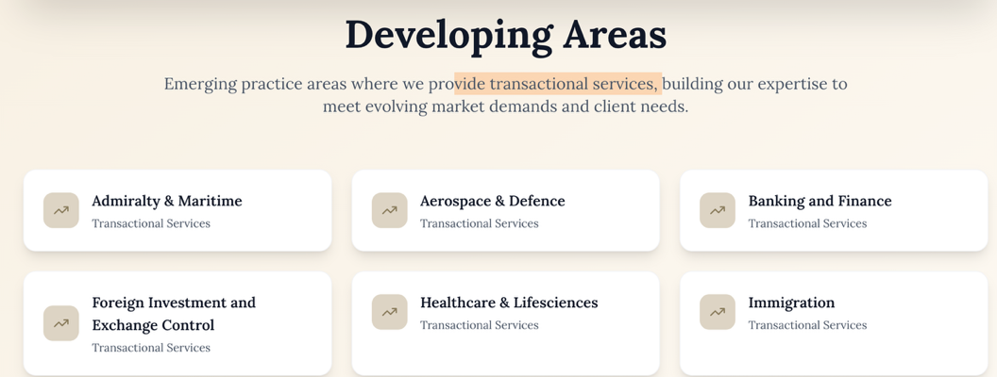



1. Sectors Tab: Featured Media to come first. Also, pls use all 3 “Technology, Media, & Telecommunications”
2. Learners Page: Delete fully “stay informed etc… Because presently, I don’t want to mention that its from expert analysis and experienced legal team. Same changes at the end where its written to subscribe. Just mention “To subscribe to our articles, blogs”. Rest all seems fine.



1. Contact Us:
   * + Send us message box is good. Just change “Ready to discuss etc” to “For inquiries, please fill in the form below and we will revert shortly”
     + Add location map.
     + Email Id needs to be [info@hralegal.com](mailto:info@hralegal.com) or something like that and not my email id.
     + Also for now my mobile number is ok but can we change at a later date Amey?
     + Delete Office Hours completely.
     + Entire Page make it little subtle font size – Refer CAM.
2. Terms of Use, Privacy Policy and Site Disclaimer” – Pls use what I have sent. Only pending is terms of use/terms and conditions. I’ll send it to you this week for sure.

**@AMEY: I have highlighted below yellow that needs to be retained as is. Also, I will go through practice areas below mentioned vis-à-vis website you sent and check once if all is in order.**

**Index**

1. Disclaimer – THIS COMES AS A POP UP OR TO CONFIRM BEFORE USING WEBSITE.
2. About Us – Vision, Mission, Values & Culture, and Team/Founder
3. Home – HRA Legal Intro, Defining Traits, Our Services
4. Practice Areas – Expertise Areas and Developing Areas
5. Sectors
6. Learners Page –Blogs, Latest Articles [@Amey: I’m thinking of this section name. TBC]
7. Contact Us
8. Privacy Policy, Terms of Use & Disclaimer
9. Careers

**POP UP**

**Disclaimer – [@Amey : Keep button to click “agree” / “accept” or “reject”. If rejected then website wont move forward]**

As per the rules of the Bar Council of India, lawyers and law firms are not permitted to solicit work or advertise. By clicking on the "I Agree" button, you acknowledge and confirm that you are seeking information relating to HRA Legal on your own accord and that there has been no advertisement, touts, personal communication, solicitation, invitation or any other inducement of any sort whatsoever by or on behalf of HRA Legal or any of its members to solicit any work through this website.

**PAGE 1**

**HOME**

1. **Introduction:**

HRA Legal is a professional law firm with specialized expertise across various legal disciplines, including Civil and Business Law, Intellectual Property Laws (with a niche focus on Media & Entertainment, Technology, and Sports), Corporate and Commercial Law, Company Secretarial and Corporate Governance, Employment and Labor Laws, Environment Law, Property Law, Taxation Law and other developing areas of law.

At HRA Legal, our seasoned and diligent lawyers provide personalized solutions to cater to the specific requirements of each client. We pride ourselves on delivering prompt, reliable and qualitative services that enables businesses to navigate the complexities of the law with confidence and clarity.

1. **Our defining traits – why choose us?**
2. Effortlessly Comprehend the deal/matter
3. Effective Structuring and Strategizing the deal from legal and commercial perspective
4. Confident Negotiations [with mix of Negotiation Styles-Integrative, Distributive or Adversarial, keeping in mind Zone of Possible Agreement and Best Alternate to Negotiated Agreement]
5. Successful deal closures
6. Leadership (Flexible Thinking amid constantly shifting situations and risks)
7. Always Accessible for Advice/Consultations (Paperwork must, before you make any commitments)
8. **Services**

* **Primary Services:** 
  + Deal Structuring with / without commercials
  + Contract Drafting, Reviewing, Negotiating and Execution
  + Setting Up of Policies, Framework and Manuals
  + Research and Opinions
  + Consultations & Advisory
  + Standards and Practices
* **Secondary Services:**
  + Legal Software Customizations
  + Project Management
  + Setting up Legal Processes Flow Charts and Standard Operating Procedures
  + Trainings and Presentations

HRA Legal offers end-to-end Legal services, including, structuring, drafting, negotiation and execution of all types of contracts/agreements/documents/paperwork (including definitive agreements, long form agreements, founder agreements, non-disclosure agreements, no objection certificates, letters, agency agreements, et al), sending notices & replies, legal research and analysis, consultations and advisory services, policy drafting and its implementation manual, tabulating databases, setting up of processes, systems, SOP’s (standard operating procedures), providing opinions & solutions, et al for established and emerging businesses, and/or managing entire legal department of your company.

Our detailed services for each area of practice can be referred in its respective tab.

**Page 2 - About HRA Legal – Mission, Vision, Values and Culture**

1. **Our Story**

Our Story - Rushi to draft and provide

HRA Legal works on an ever evolving and diverse outlook consistently aligned with the prevalent market dynamics, and technology shifts. Just like technology, law is continuously evolving, and so does HRA Legal.

1. **Mission**

Our mission is to deliver outstanding professional legal services to a diverse range of global and domestic clients, including governments and economic entities, while upholding a strong focus on our Core Values, consistent profitability, long term sustainability, and social responsibility, while fostering a dynamic, passionate and inclusive work environment for our professionals.

1. **Vision**

Our vision is to be a renowned profitable premier law firm globally.

1. **Core Values**

Our core values of Integrity, Trust, Respect, Humility, and Unity are consistently reflected in our business ethics and are embedded in the professional legal services we offer worldwide.

1. **Culture**

Our culture is driven by an entrepreneurial mindset, strong conviction, principled leadership, resilience, continuous learning, and focus on work-life balance, all fostered within a vibrant and enjoyable workspace.

1. **Core Team**

**Rushi Upadhyaya**

Rushi Upadhyaya, Founder of HRA Legal. She holds master’s degree in Masters of Business Laws (MBL), and is a qualified Company Secretary, and further holds post graduate degree in Diploma in Intellectual Property Laws (PGIPR), and is a law graduate (LLB) along with a management graduate (BMS).

She has an experience of 15+ years as an in house ***Counsel -*** ***Legal, Corporate Affairs and Business Affairs*** in Media & Entertainment sector, and has worked with global and multinational companies including Sony Pictures Networks India Pvt. Ltd. (now Culver Max), Shemaroo Entertainment Ltd., Goldmines Telefilms Ltd., Reliance Industries Ltd.-Jio Studios, Sony Music (India) Pvt. Ltd., Maddock Films, and as a consultant at Reliance Retail.

With her good educational foundation and enriching experience in Legal, Corporate Affairs and Business Affairs, she is adept in structuring, negotiating and executing complex agreements for multifarious businesses, advising on corporate, commercial and intellectual property matters, standard & practices/content regulation, setting up legal processes/ systems/ standard operating procedures and leading corporate matters including mergers and acquisitions.

Core skills that define her includes a sharp leadership mindset, prompt decision making, strong analytical and meticulous approach, proficiency to provide strategic and prolific suggestions, and competence to provide balanced solutions for a win-win closure.

**Ami Upadhyaya – Independent Consultant**

Ami Upadhyaya, Founder of HRpreneurs (human resources service provider). She is a Management Graduate (BMS), with triple masters [Master of Commerce (MCom), Master of Business Administration (MBA), and Master of Business Laws (MBL)] and is a certified/licensed Neuro linguistic (NLP) practitioner.

She has an experience of 18+ years as a Human Resource Professional in IT and Real Estate sector and has worked with global and multinational companies including PXL Soft, Karizma, Sethia Pride, and One Avigna.

With her good educational foundation and enriching experience in Human Resources and Management, she is adept in all human resources and management functions including Recruitment, Salary, Performance Appraisals, Taxation, Benefits and Compensation (including ESI &, Gratuity), Preparing Policies (including Prevention of Sexual Harassment, Code of Conduct, Diversity and Inclusion), Inductions and Orientations, Training & Development, and Leadership Training & Management.

Core skills that define her includes entrepreneurial aptitude, effortlessness approach in conventional and new ideas, profound comprehension of business, self-assertive, and a risk taker.

**Page 3**

**PRACTICE AREAS – EXPERTISE AREAS AND DEVELOPING AREAS**

1. **Expertise Areas**
2. **CONTRACTS, COMPLIANCES, AND ADVISORY**

1. **CONTRACTS/AGREEMENTS DRAFTING / REVIEW, NEGOTIATIONS AND EXECUTION**
2. **General Agreements-Drafting/Reviewing**: Creating customized contracts: partnership agreements, purchase and supply agreements, service agreements, sale agreements, franchise agreements, licensing agreements, distribution agreements, vendor contracts, non-disclosure agreements (NDAs), employment contracts (including offer letters, performance appraisal letters, termination letters), annual maintenance agreements, indemnity agreements, et al.
3. **Digital Agreements**: Drafting, Reviewing, Negotiation and/or Execution of:
   1. **Electronic Agreements** : software licenses, cloud service agreements, and digital content licensing and distribution.
   2. **Licensing & Distribution Agreements**: for digital products, including software, online content, and digital assets (e.g., music, videos, apps, and e-books).
4. **Technology and SaaS Agreements:** Drafting and /or Reviewing of
   1. **Software-as-a-Service (SaaS) Agreements**: SaaS agreements for digital platforms providing subscription-based software services, including service level agreements (SLAs), uptime guarantees, and data security provisions.
   2. **End User License Agreements (EULA):** EULAs for software applications, digital products, or mobile apps to outline usage rights, restrictions, and user responsibilities.
5. **E-Commerce Agreements**: Drafting, Reviewing, Negotiation and/or Execution of:
   1. Terms and Conditions/terms of use, privacy policies, and return/refund policies.
   2. **E-Commerce Platform Agreements**: terms of use, seller agreements, affiliate contracts, and product listing terms and conditions.
   3. **Payment Gateway Agreements**: contracts with payment service providers and ensuring compliance with payment security standards (e.g., PCI-DSS)**.**
   4. **Advertising and Marketing Agreements**: digital marketing activities, including influencer marketing contracts, affiliate marketing agreements, and advertising terms.
6. **Sales and Distribution Agreements**: Drafting, Reviewing, Negotiation and/or Execution of contracts related to the sale and distribution of goods/services, including e-commerce-specific agreements.
7. **Subscription Agreements**: Reviewing agreements for subscription-based businesses (either free or advertisement or pay basis), outlining terms for recurring billing, customer rights, and cancellation policies.
8. **Other Agreements** in relation to each Area of Practice is mentioned in its respective header.
9. **COMPLIANCES AND ADVISORY**
10. **Privacy and Data Protection** 
    1. **Data Processing Agreements:** Drafting, Reviewing, Negotiation and/or Execution of agreements between e-commerce platforms and third-party vendors who handle customer data, ensuring compliance with data protection laws and outlining data processing terms.
    2. **Data Protection and Privacy Policies**: Drafting privacy policies and data protection clauses and/or agreements to comply with local and international laws.
    3. **Cookie and Tracking Consent**: Ensuring websites comply with the legal requirements related to cookie usage, online tracking, and obtaining consent for data collection and processing.
11. **Consumer Protection Compliances**: Advising on compliance with consumer protection laws such as the Consumer Protection Act, IT Act, Data Protection Laws, and laws relating to refunds, warranties, and product guarantees.
12. **E-Signature Legal Advisory**: Advising businesses on the use of electronic signatures (e-signatures) to ensure they are legally compliant.
13. **Regulatory Research and Compliance for E-Commerce / Retail Businesses**
    1. **Online Retailer Regulatory Compliance**: Offering advice on compliance with industry-specific regulatory framework for e-commerce, such as health and safety standards, online pharmacy, and product liability issues for consumer goods sold online.
    2. **Advertising and Marketing Compliance**: Ensuring compliance with advertising laws, including the use of consumer data for targeted marketing, and compliance with advertising standards set by regulatory bodies in respective industry / sector.
14. **Intellectual Property** 
    1. **Intellectual Property Protection:** Advising on protecting intellectual property (IP) such as trademarks, patents, and copyrights for all contracts as enlisted hereinabove.
    2. **Copyright Infringement and Enforcement**: Advising on strategies to protect and/or defend potential copyright infringement in the media, digital and e-commerce space, including issuing takedown notices, replies, and managing IP disputes, however not litigations.
15. **Indemnity, Liability and Dispute Resolution** 
    1. **Disputes**: Drafting Notices/ Replies and/or Advising businesses on handling fraudulent transactions, non-performance, breach, delivery disputes, payment disputes et al.
    2. **Indemnity Agreements / Clauses:** Drafting / Reviewing / Negotiating Indemnity and Liability Agreements / Clauses. This includes sending notices/ replies to seek or defend Indemnity.
    3. **Dispute Resolution Agreements / Clauses:** Drafting / Reviewing / Negotiating clauses for dispute resolution, including, deadlock clauses, escalation matrix’s, conciliations, mediation, Governing Law, and Arbitration provisions.
16. **General End-to End Documentation :** Bearing in mind the deal structure, we assist in :
    1. **Drafting / Reviewing:** on certain crucial (protective/defensive) clauses such as strengthening of commercial structure (including fundamental purpose, payment terms vs completion milestones, delivery obligations & date), obligations, representations and warranties, indemnity, limitation of liability, termination provisions, and dispute resolution.
    2. **Negotiation of Commercial Terms**: to ensure favourable business conditions and legal protection.
    3. **Enforcement & Performance:** Providing advice on enforcing and managing contractual obligations, as well as assisting in cases of non-performance or breach.
    4. **Exit Clauses & Termination**: Drafting termination provisions, including those for early termination, dispute resolution, and exit strategies.
17. **COMPANY SECRETARIAL AND CORPORATE GOVERNANCE**
18. **COMPANY SECRETARIAL**:
19. **Corporate Structure & Formation**: Drafting, Reviewing and/or Advising on appropriate legal structure for businesses (e.g., corporation, limited liability company, partnership) and assisting with company formation, its documents, and registration.
20. **Board Governance**: Drafting, Reviewing and/or Advising on corporate governance best practices and policies, charter documents [such as Certificate of Incorporation (COI), Articles of Association (AoA), shareholder agreements, shareholder rights], board structures, duties and power of directors, rules for board meetings, agenda, minutes, and resolutions, and ensuring compliance with legal obligations related to corporate meetings.
21. **Regulatory Compliances**: Drafting, Reviewing and/or Advising on compliance of relevant local, national, and international corporate laws, governance framework, and regulations, such as ministry of information and broadcasting, Securities Exchange Board of India, securities regulations, and industry-specific regulatory and compliance requirements (e.g., media, healthcare, et al).
22. **Corporate Filings & Reporting**: Drafting, Reviewing and/or Advising on compliance of filings, forms, annual returns/reports, corporate disclosures to regulatory authorities, and any other required corporate documents.
23. **Corporate Record Keeping**: Ensuring the proper maintenance of corporate records, registers of shareholders and directors, and other statutory documents.
24. **Regulatory Filings and Updates**: Drafting, Reviewing and/or Advising on regulatory filings, including changes in directorship, shareholding, and company structure, ensuring all changes are duly recorded and filed with the appropriate authorities.
25. **CSR, Sustainability and ESG (Environmental, Social, and Governance):**
26. **Sustainability and ESG :** Offering legal counsel on sustainability initiatives, corporate social responsibility (CSR), and meeting ESG criteria in corporate governance.
27. **Corporate Social Responsibility (CSR):** Drafting, Reviewing and/or Advising on CSR Policies, CSR strategies and ensuring compliance with regulations related to environmental impact, ethics, and corporate transparency and good governance.
28. **CORPORATE FINANCING AGREEMENTS**
29. **Investment Agreements**: Drafting / Reviewing/ Negotiating investment agreements between investors and companies, including shareholder agreements, venture capital, and private equity investments.
30. **Debt & Refinancing**: Assisting with review of loan agreements, debt restructuring agreements, refinancing existing debt agreements.
31. **Bank Guarantees**: Reviewing of Bank Guarantees and Indemnity Agreements.
32. **CORPORATE RESTRUCTURING, INSOLVENCY AND BANKRUPTCY**
33. **Restructuring Research & Advisory:** Offering research of current laws and regulations in relation to restructuring corporate debt, equity, and operations to improve financial health
34. **Insolvency and Bankruptcy**: Offering research of current laws and regulations on insolvency proceedings, liquidation, creditor rights, bankruptcy filings, and bankruptcy protection.
35. **Debt Restructuring**: Assisting and Collaborating with in-house counsels with debt restructuring processes, including negotiating with creditors, refinancing, or converting debt into equity.
36. **Corporate Reorganization**: Assisting and Collaborating with in-house counsels for research and review of corporate reorganizations agreements, such as spin-offs, and mergers, to improve operational efficiencies or address financial difficulties.
37. **Liquidation and Winding-Up**: Assisting and Collaborating with in-house counsels for liquidation or winding-up processes, including the appointment of liquidators, asset distribution, and creditor settlements.
38. **COMPLIANCE, BRIBERY, ANTI-CORRUPTION, & WHITE COLLAR CRIME**
39. **Compliance Program Development**: Assisting businesses in designing, drafting and implementing compliance programs, policies, and procedures to adhere to laws and regulations across industries (such as anti-money laundering (AML), anti-bribery and corruption (ABC), data protection).
40. **Anti-Corruption and Anti-Bribery Policies**: Drafting / Reviewing anti-corruption and anti-bribery policies in accordance with international standards (e.g., Prevention of Money Laundering Act, 2002 (PMLA), the UK Bribery Act, the US Foreign Corrupt Practices Act). This also includes providing a standard provision for Anti Bribery / Anti-Corruption / Data Protection which can be incorporated in all legal documents of the company.
41. **Whistleblower Protection**: Advising on whistleblower protection programs, including drafting whistleblower policies, setting up reporting mechanisms and escalations, implementation process & its documentation.
42. **Penalties and Settlements**: Assisting company with internal drafting and negotiating internal settlements, and remediation documents.
43. **Presentations:** Presentations to the company and its employees of the salient features, fundamental provisions, do’s and don’ts et al of the aforementioned laws.
44. **INTERNATIONAL TRADE & EXPORT/IMPORT ADVISORY**
45. **Trade Compliance**: Advising and providing opinion on compliance with import & export control laws, customs rules and regulations, duties, tariffs, taxes, sanctions, and international trade agreements, treaties & conventions,
46. **Cross-Border documentation**: Drafting, Reviewing and Negotiating international agreements & all allied documents, related to the export and import of goods and services ensuring compliance with international trade laws and regulations.
47. **DATA PRIVACY, PROTECTION, AND CYBERSECURITY**
48. **Data Privacy Compliance**: Advising businesses on compliance with data privacy laws and regulations including the drafting of privacy policies and data processing agreements.
49. **Cross-Border Data Transfers**: Advising on the legal complexities of transferring data across borders, including compliance with international data transfer agreements.
50. **Third-Party Data Contracts**: Drafting and negotiating data-sharing and data-processing agreements with third-party service providers to ensure compliance with privacy and security standards.
51. **EMPLOYMENT, LABOUR & INDUSTRIAL RELATIONS**
52. **Employment Contracts and Policies**: Drafting and Reviewing employment contracts, offer letters, termination letter, exit/relieving letters, experience letters et al, Drafting Policies [for Prevention of Sexual Harassment at Workplace (POSH), Code of Conduct, Social Media, Diversity and Inclusion), and Employee Handbooks to ensure compliance under various labour laws, employer duties, and employee rights.
53. **Employee Benefits and Compensation**: Advising on structuring employee benefits packages, including pensions, gratuity, insurance, bonuses, allowances, and reimbursements.
54. **Labor Disputes**: Representing company in internal settlements or disputes with employees, including wrongful termination, wage claims, and workplace harassment claims.
55. **Workplace Safety and Compliance**: Ensuring compliance with health and safety regulations in the workplace, and advising on risk management.
56. **Redundancy and Layoffs**: Advising on legal compliance during layoffs, redundancies, or workforce downsizing, including compensation, severance package issues & its documentations.
57. **Development Programs, Training, Induction:** Conducting trainings / presentations for self-development, leadership development, induction programmes, orientations, legal presentation for adherence to various mandatory compliances et al.
58. **REAL ESTATE**
59. **General Agreements:** Drafting (based on client’s existing templates), and/or Reviewing, all service agreements, procurement agreements, supply agreements, marketing agreements, employment agreements, confidentiality & non-disclosure agreements, general and specific power of attorneys, no objection certificates, transfer deed, gift deed, and other additional documents on a case to case basis.
60. **Property Transactions**: Drafting (based on client’s existing templates), and /or Reviewing agreements in relation to the buying, selling, licensing, leasing, and development/re-development of real estate. This includes *drafting* *and reviewing* of partnership agreements including limited liability partnerships, project management agreements, title deed, purchase agreements, sale agreements, possession letter, allotment letter, conveyance deeds, permanent alternate accommodation agreements, shareholder agreements, and any other related documents.
61. **Landlord and Tenant Relations**: Drafting (based on client’s existing templates) and/or reviewing commercial and residential lease agreements, leave and license agreements, their amendments, renewals, and termination letters.
62. **Research**: Research and Advising developers / tenants / members on zoning regulations, environmental regulations et al.
63. **STARTUPS & EMERGING BUSINESSES**
64. **Business Formation and Structure**: Advising on the most appropriate business structure (e.g., LLC, corporation, partnership), and assisting with the formation and registration of startups.
65. **Contract Drafting**: Assisting with the drafting of founder contracts, employment contracts, customer agreements, licensing agreements, Merger/JV agreements, franchise agreements, distribution agreements, marketing/branding/advertising/digital advertising agreements, and all key contracts needed by startups.
66. **Intellectual Property Protection**: Helping startups protect their ideas, including drafting IP agreements.
67. **MERGERS AND ACQUISITIONS, JV’s, STRATEGIC ALLIANCES**
68. **Due Diligence**: Conducting thorough legal due diligence for mergers, de-mergers, acquisitions, and investments to identify legal risks, liabilities, and opportunities.
69. **M&A Structuring and Strategy**: Advising on the optimal structure for mergers and acquisitions and negotiating terms to maximize value and minimize risk.
70. **M&A Agreements**: Drafting, Reviewing and Negotiating term sheets, LOI’s, definitive agreements, share purchase agreements (SPAs), shareholder agreements, assignment agreement, novation agreement, intimation letters, and other related documents.
71. **Joint Venture Agreements**: Drafting, Reviewing and Negotiating joint venture agreements, including the terms of collaboration, capital contributions, profit-sharing, et al.
72. **Strategic Alliances**: Drafting strategic alliance agreements, partnerships, collaborations, including defining roles, responsibilities, and profit-sharing mechanisms.
73. **Post-M&A Integration**: Advising on the post-transaction integration of businesses including forms, filings, employee retention, compliance with existing contracts, and restructuring et al.
74. **Regulatory Approvals and Notifications**: Advising for regulatory filings.
75. **Risk Allocation and Dispute Resolution**: Drafting risk allocation clauses and providing dispute resolution mechanisms in joint venture and collaboration agreements.
76. **INTELLECTUAL PROPERTY**
77. **Trademark and Copyright Protection**: Advising on the protection and registration of trademarks, copyrights, and other IP assets, including licensing and enforcement.
78. **IP Licensing and Monetization**: Advising on strategies to monetize intellectual property through licensing, franchising, and joint ventures.
79. **Brand Protection and Enforcement**: Representing clients in enforcing and defending their intellectual property rights, including trademark/copyright infringements, and takedown notices.
80. **IP Portfolio Management**: Assisting businesses in managing their IP portfolios, including IP audits, and licensing agreements (and its renewals).
81. **MEDIA, TECHNOLOGY, AND TELECOMMUNICATIONS**

**HRA Legal have enriching experience of close to 2 decades in Media and Entertainment sector, with a nuanced understanding of all the paperwork, processes, procedure involved during the stages of content making i.e., pre-development, development, production, releases, and post release.**

1. **Pre-Production**: This phase involves the preparation and planning before the actual filming begins. It includes:
2. **Development Agreements**
3. **Development including First Look or Exclusive Arrangements : Agreements that records the initial pre-production stage of the content such as script development, finalisation of star cast, director budget and location to determine whether to proceed with further production and financing.**
4. **Option Agreements**: Agreement between a production company and a writer or rights holder to option the rights to a script or intellectual property (e.g., books, TV shows, etc.) for a certain period. These are usually the format rights, adaptation agreements, book option agreements, remake rights, and life story rights.
5. **Writer's Agreements**
6. **Financing Agreements** such as Co-Financing agreements (multiple production companies or investors contribute funds to the project) or Investment agreements (investor terms for profit sharing and equity in the project).
7. **Talent and Crew Agreements** such as Actor, Director/Producer Agreements, etc.
8. **Location and Rights Agreements**
9. **Location Releases**: Legal permission to shoot on specific locations.
10. **Music & Images Licensing**: If pre-existing music & images are to be used, appropriate rights clearances/paperwork.
11. Advising on elements for **Production or Media liability insurance** coverage for any unexpected events during production, including cancellation, injury, property damage or rights infringement.
12. **Script Reviews** to identify non-compliances or violation of any media laws/regulation in order to avoid future claims or liabilities.
13. **Production**: This phase includes the actual filming and recording of the media content. It includes:
14. **Production Agreements: Structuring, and Drafting / Reviewing all kinds of master production agreements including Co-Production, Commissioning/Work-For-Hire, Production cum Assignment Agreement, Direct Acquisition (ready content) Agreements, and such other prevalent structures in industry.**
15. **Talent and Crew Agreements**
16. **Above-the-Line Contracts: For principal talent (actors, directors, casting director, producers, writers, lead star cast, music composer, lead singers etc.).**
17. **Below-the-Line Contracts: For crew members such as line producer, cinematographers, art directors, costume designer, sound engineers, costume designers, etc.**
18. **Union and Guild Agreements**
19. **Copyright and Trademarks**
20. **Copyright Registration**: Ensure that the intellectual property of content production (script, footage, music, etc.) is copyrighted.
21. **Trademark Protection**: Ensure new fictional brand, logo, or show name created does not infringe any existing third party IP.
22. **Third Party Production Agreements**
23. **Subcontractor Agreements: for set design, special effects like VFX etc.**
24. **Product Placement Agreements: for in-film placement, standard associate-presenter credit (barter/paid), co-branding promotions etc**
25. **Marketing Agreements: for television, radio, print, outdoor advertising, and online media advertising etc**
26. **PR Agreements**
27. **Post-Production**: Once filming is completed, the content goes through editing, sound design, visual effects, and other post-production processes. It includes:
28. **Post-Production Agreements**
29. **Editor Contracts**: for final edit/cut of the content as per creatives/script review.
30. **Soundtrack and Music Licensing** for BGM and third party music synchronisation.
31. **Distribution and Licensing Agreements**
32. **Distribution Agreements**: for distribution of the content across various platforms (e.g., theatrical, satellite, digital, in-flight streaming etc).
33. **Merchandising Rights**
34. **Non-Disclosure Agreements for Test Screening and Feedback** to ensure confidentiality and protect intellectual property.
35. **Licensing and Distribution Agreements**: After production, specific contracts for distribution of the content. It includes:

1. **Theatrical Distribution**
2. **Television/Satellite Distribution**: Includes terms for the sale or licensing of content to TV networks via various types of satellite rights such as Terrestrial Television, Pay Television, Free Television, Free-to-Air Satellite rights, Pay-Per-View/Day, Cable TV Rights, etc
3. **Digital Distribution:** Includes terms for the sale or licensing of content to TV networks via various types of digital rights either on streaming and download basis such as Video on Demand – Transaction VOD (YouTube/Apple TVOD), Subscription VOD (eg: Netflix), Advertising VOD, Near VOD, Free VOD (YouTube)
4. **Music Distribution**: Agreements for the use of music in film or TV shows. These agreements typically cover:
5. Synchronization rights (for film/TV synchronization).
6. Master rights (for recorded music).
7. **Music Publishing Agreements**: for composers and songwriters to manage and license music used in the production.
8. **Home Video**
9. **International Sales Agreements**
10. **Surface Transport Agreements including inflight, etc**
11. **Standards and Practices (Content Viewing & Opinions)**: In addition to the legal documents, in India, Standards and Practices related to content viewing and opinions are primarily governed by a mix of statutory regulations and self-regulatory mechanisms. These guidelines are meant to ensure that content aired on television, the internet, and other media platforms adheres to certain ethical, moral, and legal standards. This is most pertinent step to avoid any potential claims, liabilities or litigations on a later date during or after release of the content. The main framework includes adherence to:
12. **Cable Television Networks (Regulation) Act, 1995:**
13. **To prohibit obscene, violent, or harmful content on TV, and**
14. **To Regulate advertising to avoid misleading or indecent material.**
15. **Cinematograph Act, 1952**
16. **Governs film censorship.**
17. **Films are certified (e.g., U, UA, A) based on content suitability.**
18. **Information Technology (Intermediary Guidelines and Digital Media Ethics Code) Rules, 2021:**
19. **Applies to digital content (OTT, social media).**
20. **Requires content classification and grievance redressal.**
21. **Prohibits content harmful to national security, minors, and public morality.**
22. **Broadcasting Content Complaints Council (BCCC): to oversee ethical content in broadcasting (TV)**
23. **Press Council of India (PCI): To regulate print media and online news portals for ethical reporting and accuracy.**
24. **Indian Penal Code (IPC):**
25. **Addresses issues like obscenity, hate speech, and defamation**
26. **Prohibits blasphemous or offensive content.**
27. **Advertising Standards Council of India (ASCI): Regulates advertisements to ensure they are truthful, decent, and not misleading.**
28. **Self-Regulation by OTT Platforms:**
29. **Platforms classify content (e.g., U, A, etc.).**
30. **Prohibit explicit content and provide clear warnings.**
31. **Satellite, Broadcasting, & Digital Agreements: In addition to the above, we also draft and negotiate following:**
32. **Channel Agreements : TV Serials Production Agreements, Commissioning Agreements, Deed of Assignments for underlying works, OAP Agreements, Marketing, Advertising, Research & Placement Agreements et al**
33. **Web-Series/Short Formats (Fiction/Non Fiction) Productions**
34. **Formats (Hindi – Fiction and Non-Fiction)**
35. **Digital Agreements including Acquisition, Original Productions, Privacy Policy, T&C’s et al**
36. **Syndication or Distribution Agreements for various media rights (Satellite + Digital + Music + Ancillary)**
37. **Channel (as a whole) Distribution & Affiliation Agreements**
38. **Post-Production, Finance, Ad Sales & Human Resource Agreements**
39. **Artist Agreements, Voice over services, music composer, designers, stylists, publishers, authors agreements (for literary, dramatic, musical), teleshopping, forwarding & distribution agency, Contest terms and conditions, PR Agency, advertising agency, Events, Promotions, Marketing, etc.,**
40. **Strategic Ventures (Corporate Actions- Documentation wrt Merger, Demerger, Acquisition of Company)**
41. **Value Added Services Agreement & Integration Agreements**
42. **Litigation & Miscellaneous**
43. **Music Agreements:**
44. **Music Streaming Agreements**
45. **Music Acquisitions (across all genres Bollywood, South, North, Pop, and A&R)**
46. **Music Production (& all Underlying Works including Lyricist, Music Composer, Singer, Performer et al)**
47. **Artist Recording / Sound Recording Assignment Agreements**
48. **Publishing Agreements**
49. **Synchronization Agreements**
50. **Technology Contracts**: Software customization, software development agreements, SaaS agreements, integration agreements, AMC contracts, payment gateway agreements, gaming development agreements, service level agreements, short messaging service agreements, and IT outsourcing contracts.
51. **Telecommunications** **Regulations**: Providing counsel on telecommunications regulations, spectrum licensing, and compliance with government regulations related to telecommunications services.
52. **Media Projects**:
53. Designing agreement requisition forms / purchase requisitions
54. Templatization of all types of agreements
55. Rights Management System - Customization and Execution
56. Designing Contractual Matrix to simplify the documentation process
57. Standard Operating Process - for Legal Documentation Agreements request until its Execution
58. Prepare framework for Industry Matters / Policies
59. **General Matters**: Apart from all enlisted above, we further conduct Due Diligence of the Content/Corporate Actions/Party etc to ensure clear title or chain of documents.
60. **PROJECT MANAGEMENT**
61. **Legal & HR Project Management**: Managing complex legal projects such as Contract Management, Standard Operating Procedures, Rights (media) Management, Human Resources – ERP, SAP, Standard Legal Clauses Framework, Escalation Matrix’s, Workflows et al.
62. **Contract Lifecycle Management**: Assisting in managing the entire lifecycle of contracts, from drafting and negotiation to execution and termination. This includes customization of the software, preparing basic templates, contract tracking, renewals, and ensuring compliance with the agreed terms.
63. **Data Management System**: Assist in preparation of uniform title / nomenclature, numbering system, manuals, excels, workflow for managing the data in electronic file and physical file formats.
64. **Assist in Software Customization:** Assist in customization/design of digital platforms or software solutions for automating contract creation, storage, and management or any other legal processes. This includes the standard operating procedures, and varied matrix that are required for optimizing the goods/services to maximize the revenues.
65. **TAXATION**
66. **Corporate Tax Planning**: Offering advice on tax-efficient business structures and operations, including transfer pricing, VAT/GST, and cross-border tax considerations.
67. **Tax Compliance**: Ensuring businesses comply with local, national, and international tax laws, including filing returns and maintaining proper documentation.
68. **Tax Disputes and Litigation**: Representing clients in disputes with tax authorities, including appeals, audits, and negotiations to resolve tax-related issues.
69. **Tax Structuring for M&A**: Advising on tax-efficient structuring of mergers, acquisitions, and other corporate transactions to minimize liabilities and optimize tax outcomes.
70. **AI, BLOCKCHAIN, METAVERSE, NFT**

**Advising and/or Drafting, Reviewing, Negotiation & Execution of:**

1. **Artificial Intelligence (AI)**
2. **Agreements**: AI development, licensing, and partnerships between AI providers, users, and collaborators.
3. **Regulation and Compliance**: Guidance on complying with existing laws and regulations governing AI technologies, such as data protection, privacy, and ethical standards, including compliance with GDPR, and other regulations when processing personal data.
4. **Blockchain**
5. **Agreements**: blockchain transactions and decentralized applications (DApps).
6. **Regulation and Compliance**: Guidance on navigating regulatory frameworks for cryptocurrency transactions, including Anti-Money Laundering (AML) and Know Your Customer (KYC) obligations.
7. **Metaverse**
8. **Agreements**: Drafting/Reviewing agreements related to virtual real estate, avatars, and digital assets within the metaverse, including licensing and ownership terms.
9. **Metaverse Intellectual Property**: Advising on NFTs, legal rights and ownership of digital real estate, protection of virtual assets, trademarks, and copyrights in virtual worlds, and other IP assets in the metaverse.
10. **Regulation and Compliance**: Ensuring metaverse activities comply with global legal and regulatory frameworks, such as consumer protection, taxation, and data privacy laws including user data privacy, security standards, and managing user consent in virtual environments.
11. **Non-Fungible Tokens (NFTs)**
12. **Agreements**: Drafting/Reviewing agreements related to the creation, license, sale, and transfer of NFTs, including its intellectual property rights and resale terms, and terms of service and privacy policies.
13. **NFT Intellectual Property Protection**: Advising creators and buyers on IP ownership related to digital art, collectibles, and other NFTs, and further provide guidance on managing risks such as fraud, misrepresentation, and copyright infringement within the NFT market.
14. **Regulation and Compliance**: Ensuring NFT platforms comply with certain laws, such as anti-money laundering (AML) and KYC regulations, consumer protection laws, taxation implications of buying, selling, and holding NFTs, including capital gains and VAT (value-added tax).
15. **Developing Areas – Transactional only**
16. Admiralty & Maritime
17. Aerospace & Defence
18. Banking and Finance
19. Foreign Investment and Exchange Control
20. Healthcare & Lifesciences
21. Immigration
22. Insurance
23. Mining & Resources
24. Oil, Gas, Energy & Infrastructure
25. Private Equity, Venture Capital & Funds

**Page 4**

**Sectors**

1. Banking
2. E-Commerce & Retail
3. Energy
4. Education & Learning
5. FMCG’s
6. Internet
7. Infrastructure
8. Insurance
9. Media & Entertainment (Productions, Theatres, Satellite, Digital and Music)
10. Pharmaceuticals, Healthcare & Life Sciences
11. Publishing
12. Real Estate
13. Technology & Telecommunications
14. Textiles

**Page 5**

**Careers**

Internship : Please write to us at [**] along with a letter of interest showcasing your educational qualifications and future career path and goals.

Retainership : Please write to us at [**] along with a letter of interest showcasing your educational qualifications and future career path and goals.

**Page 6**

**Contact Us**

Email Id : rushi@hralegal.com

Phone Number : 9967382875

Office Address : 93 East Building, 705, Mahakali Caves Road, Near MIDC/Ahura/Onida, Andheri East, Mumbai 400093.

LinkedIn link

Instagram link

Facebook link

**Privacy Policy**

**Terms of Use**

**Disclaimer**